|  |  |
| --- | --- |
| **Class Project** | **Mohammad Movahhed** |
| **AI for Urban Water Networks** | **UB #50532691** |

**Surrogate Modeling of Drainage Networks Under Coastal Flooding**

**Introduction**

Hurricanes elevate water levels in large bodies of water due to low air pressure and strong winds, leading to storm surges that can result in severe flood inundation of coastal regions (Bentivoglio et al. 2022). Recent severe hurricanes in the United States, such as Katrina (2005), Sandy (2012), Ida (2021), and most recently Milton (2024), have caused significant economic and human losses. Coastal cities are especially susceptible to surge-driven coastal flooding caused by hurricanes due to their locations, rapid urbanization, and dense population. Surge-driven coastal floods can be simulated by hydrodynamic models (HMs). HMs are mathematical models that try to replicate the flow by numerically solving the shallow water equations (SWEs), a system of partial differential equations (PDEs) that govern fluid motion in shallow regions. While there has been extended research on developing effective HMs to accurately estimate the extent of flooding in coastal cities, the role of the urban drainage system, especially the stormwater network, is often neglected in these studies. Urban drainage systems are vital infrastructures that provide environmental protection and flood prevention by transporting sewer and runoff (caused by heavy rainfall events or storm surge) to designated wastewater treatment plants so they can be safely diverted out of the urban water cycle. The performance of drainage systems during extreme weather events is often assessed by relying on physics-based models (PMs) that abstract the physical functioning of the system (Garzón et al. 2024a). Similar to HMs, stormwater PMs numerically solve a set of governing equations, called the Saint-Venant equations, which is a one-dimensional version of the SWEs. The continuity and momentum equations of Saint-Venant can be expressed as

|  |  |
| --- | --- |
|  | (1) |
|  | (2) |

where is the flow rate, is water depth in channel, is the cross-section area, is the rate of lateral inflow (zero in 1D flow), is the channel bed slope also called the bottom slope, and is the friction slope and it represents energy loss due to friction, often calculated using the Manning or Darcy-Weisbach equations. As with all numerical models, stormwater PMs involve a trade-off between computational efficiency and simulation accuracy. This trade-off, which can be a result of utilizing different numerical approaches or different spatial and temporal resolutions, limits the application of PMs to simulate the performance of the stormwater networks during severe weather events (e.g., hurricanes), where repetitive simulation-optimizations or an instant response such as real-time control are required (Zhang et al. 2024). The computational cost of developing and utilizing accurate PMs is prohibitively high, which limits their practicality, while efficient PMs are less accurate due to simplifications, and their results may differ from reality.

An emerging alternative is to develop data-driven surrogate models (SMs) in place of PMs. SMs are mathematical approximations employed to emulate a system’s behavior, primarily to reduce the simulation time and costs (Peherstorfer et al. 2018). These models bypass the computational intensity of PMs by learning the relationships between input parameters (e.g., storm surge) and output responses (e.g., inundation) directly from pre-computed simulations. As a result, SMs enable rapid estimations, making them particularly well-suited for scenarios requiring near-real-time decision-making (Fraehr et al. 2024). In recent years, deep learning (DL) techniques and the availability of data have shown the capability of data-driven SMs in extracting complex patterns within large datasets, simulating nonlinear interactions, and predicting spatial and temporal evolution of flow dynamics with limited computational expense (Ivanov et al. 2021). In this regard, multiple DL-based SMs have been developed for stormwater networks in recent years. Zhang et al. (2019) developed an ensemble of 100 multilayer perceptrons (MLPs) and recorded that the SM was able to estimate the flow of a stormwater network 80% more accurately than a PM. Later, She and You (2019) proposed a SM based on the radial basis function (RBF) neural network to predict urban drainage outflow. In their study, the urban drainage system of Tianjin was selected as the case study, and the Storm Water Management Model (SWMM) was used as the PM. The proposed SM was validated for a single-peak rainfall event with a square sum of error of 0.273. Next, Kim and Han (2020) developed a deep neural network (DNN) with 8 fully connected hidden layers to predict the total accumulative overflow of a stormwater network using the statistical characteristics of different rainfall events as input data. A total of 70 rainfall events were used as input scenarios to train the DNN, while the output was the corresponding outflow of each event obtained from SWMM. The results showed that the developed SM was able to predict the outflow with 11% mean absolute error compared to the PM while having 99% less computational cost in terms of simulation time. More recently, graph neural networks (GNNs) have gained attention due to their inherent ability to emulate the behavior of systems that have a graph structure. In this regard, hydraulic variables of stormwater network, such as water level and flow rate, are attached to manholes and pipes, which can be represented as node and edge features in a graph. Inspired by the graph structure of urban drainage networks, Zhang et al. (2024) hypothesized that GNNs can be used as an effective spatio-temporal SM to substitute a PM for flow routing processes along the network. Their study was the first attempt to use GNNs in surrogate modeling of urban drainage networks. The GNN structure consisted of two graph convolutional network (GCN) layers that captured local interactions and routing dynamics according to the physical connectivity of the drainage network, two temporal convolutional layers to extract unsynchronized hydrodynamics in both past and future domains, and a fully connected layer before the output layer. A conventional fully connected network was also developed for comparing the performance of the GNN. The proposed SMs were trained and tested, with hydraulic prediction performances compared with simulation results obtained from SWMM. The results showed that the GNN-based SM, which was able to achieve 93% test accuracy, had the lowest root mean square error (RMSE) values across all variables compared to the conventional neural network (NN)-based models, indicating superior accuracy in numerical prediction as well. They concluded that GNNs are well-suited for urban drainage modeling due to their ability to reflect topological structure. Similarly, Garzón et al. (2024b) developed another GNN-based SM, but incorporated an encoder-decoder structure to better handle large datasets. The GNN-based SM achieved higher accuracy in predicting hydraulic heads compared to an MLP-based SM. Additionally, when trained on one part of the network, the GNN model was able to generalize well to another unseen sub-network. This is largely attributed to the ability of GNNs to exploit relational structures and easily adapt to other graph structures of the same type of physical networks.

Overall, the literature has highlighted the capability of GNNs as effective SM for stormwater networks. However, these studies have only focused on pluvial flooding, and no studies have been developed to assess their performance during storm surge-driven coastal floods. Additionally, SMs capable of providing time-series predictions are also limited in literature, and the most conventional approach to enable time-dependent predictions in SMs, i.e., lookback window, has not yet been explored for urban drainage network SMs. To address these gaps, this project attempts to develop a GNN-based SM as a substitute for a PM (SWMM) to predict the outflow time series under a coastal flood event. For this purpose, the city of Bellinge in Denmark was used as the case study, assuming that the river near the city, called Odense, is the shoreline. Figure 1 illustrates the proposed framework for developing the GNN-based SM. Initially, different storm surge scenarios were selected, and following a simple bathtub model, inundation maps were obtained for all surge time series, since using a high-fidelity HM was decided to be computationally exhaustive. Then, the inundation maps were used to find the equivalent rainfall depth and used as input to the SWMM of the urban drainage system. After obtaining the discharge time series for the outfalls of the drainage system, a GNN was developed and trained to predict the discharge time series and act as a surrogate to the computationally expensive SWMM.

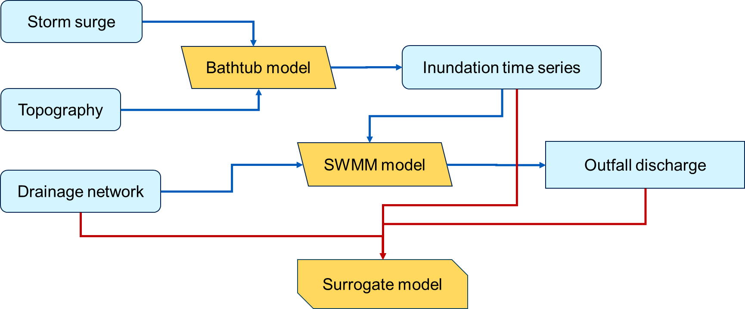

**Figure 1.** Framework and required data for developing the proposed GNN-based SM.

**Data Preparation and Modeling**

As the first step, multiple storm surge scenarios and the topology of the study are required to obtain flood inundation maps. Figure 2 shows the digital elevation model (DEM) of the study area at a 5-meter resolution along with the drainage network, where each node shows the location of an inlet or junction, and each link represents a pipe, a channel, or a conduit (Nedergaard Pedersen et al. 2021). The shoreline was also established according to the DEM. All the data for the study area, including DEM, network components, and SWMM, can be obtained from [data.dtu.dk](https://data.dtu.dk/collections/Dataset_for_Bellinge_An_urban_drainage_case_study/5029124).

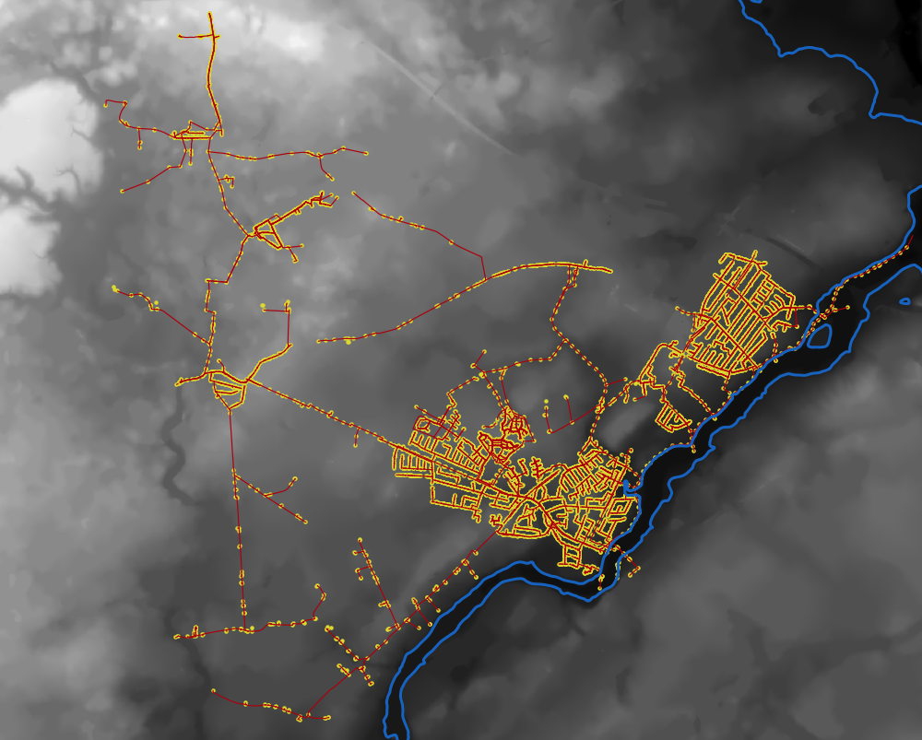

**Figure 2.** The DEM and drainage network components of the study area.

To reduce the computational cost of conducting SWMM simulations in order to be able to generate multiple scenarios, the drainage network, which is comprised of separated and combined systems, was simplified, and only the combined system was considered for this project. The simplified drainage network, along with several of its graph characteristics are shown in Figure 3. For the storm surge scenarios, the North Atlantic Coast Comprehensive Study (NACCS) database developed by the Coastal Hazard System ([CHS](https://chs.erdc.dren.mil/Home/Index)) initiative was utilized (Cialone et al. 2017). This synthetic database was developed by using the advanced circulation (ADCIRC) model and consists of several historical and synthetic hurricane simulations with various return periods along the East Coast of North America. For this project, 74 hurricane scenarios were selected with a 200-year return period and the duration of two days, and the corresponding storm surge time series of each scenario were used to acquire the inundation maps of the study area following a simple bathtub approach expressed in Equation 3.

|  |  |
| --- | --- |
|  | **Graph characteristics:**  Num. of nodes: 1020  Num. of edges: 1026  Average node degree: 2.01  Average betweenness centrality: 0.0025  Assortativity coefficient: 0.0116  Triadic closure: 0.023 |

**Figure 3.** simplified network with select graph characteristics.

|  |  |
| --- | --- |
|  | (3) |

where is the inundation depth at grid () at time , is the storm surge elevation at shoreline at time , and is the elevation of the grid () obtained from the DEM. Figure 4 shows the storm surge time series for the first five hurricane scenarios, while Figure 5 illustrates an obtained peak inundation map selected from one of the hurricane scenarios as an example.

**Figure 4.** Storm surge time series for the first five hurricane scenarios.

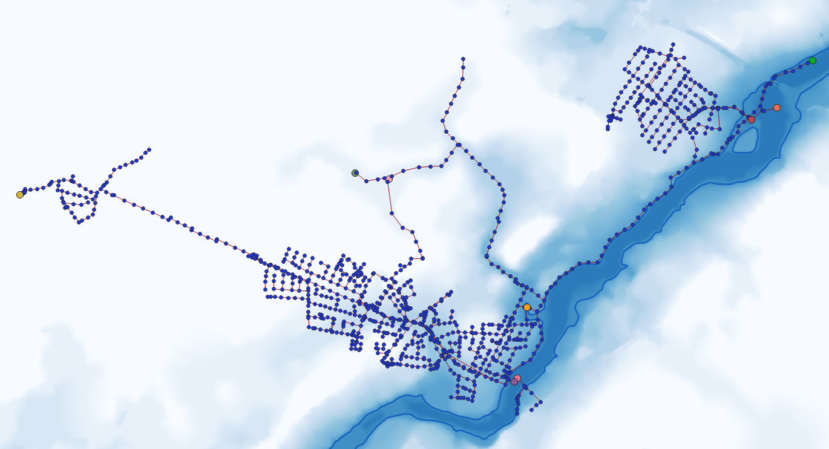

**Figure 5.** surge-induced maximum inundation selected randomly from one of the scenarios.

A MATLAB script was written and executed to obtain the inundation maps of the area for all surge scenarios at all time steps. Then, Equation 4 was utilized to obtain the equivalent rainfall depth at each time step:

|  |  |
| --- | --- |
|  | (4) |

where is the rainfall depth (mm) at time step and is the volume of accumulated water in time step , and is the inundated area at time step calculated as the number of wet cells multiplied by the area of each cell (). It should be mentioned that the uniform random number is added to the equation to introduced randomness in the data since it was later discovered that the obtained storm surge time series are similar to each other. Additionally, the coefficient 3 is in the denominator since the time step changed from 15 minutes for storm surge time series to 5 minutes for the rainfall series. Lastly, the infiltration rate was assumed to be zero for the domain.

In the next step, the SWMM model the Bellinge’s drainage network (Nedergaard Pedersen et al. 2021) was modified to the new simplified version with the new rainfall time series using the swmmio library in Python. Then, using the new rainfall depth time series, simulations were conducted for all 74 scenarios and the discharge at the 9 outfalls of the network were recorded. Figure 6 shows the discharge time series of outfalls of the network for scenario one. After examining Figure 3 with this figure, it can be seen that the outfalls closer to the shoreline have larger discharge values with higher fluctuations.

**Figure 6.** Discharge time series for outfalls of the network under scenario 01.

In the next step, the GNN was constructed with two graph convolutional layers followed by a fully connected layer with nine neurons (same as the number of outfalls). The input data for the GNN-based SM, i.e., node features, are listed in Table 1. They consist of both static and dynamic attributes following (Zhang et al. 2024); selected static features include distance to shoreline obtained by using GIS and elevation, depth, and coordinates from SWMM. The dynamic features included the time encoding, or the normalized time step, equal to the current time step divided by the total time of simulation, and past rainfall series. The past rainfall series was selected to enable the SM to produce time series predictions of discharge, and its range, i.e., lookback window, was determined to be 2 hours (spanning 24 timesteps). In other words, for predicting outfall discharge values at time step , the GNN utilizes the static features of all network nodes, combined with the current time encoding and rainfall data for the interval . The structure of the proposed model is illustrated in Figure 7.

**Table 1.** List of static and dynamic features selected as input variables for SM.

|  |  |
| --- | --- |
| Static | Dynamic |
| Elevation | Rainfall: Past 24 timesteps (2 hours) |
| Depth | Time encoding (normalized timestep) |
| X coordinate |  |
| Y coordinate |  |
| Distance to shoreline |  |
| **SUM =** | **30 features** |

**Figure 6.** The GNN-based SM structure (adopted from Kim et al. 2023).

**Results and Discussion**

For training the SM, the first 54 scenarios out of 74 synthetic scenarios generated in the previous step were selected. Owing to the size of the drainage network, each training epoch requires a relatively large duration to complete; hence, the number of epochs was set at 500. After attempting several optimizers with various learning rates, the Adam optimizer with a learning rate of was selected for training. Furthermore, a scheduler that reduces the learning rate by a factor of 0.75 if the loss value does not improve for 2 consecutive epochs was introduced in the learning process to improve training convergence. For the loss function, the mean square error (MSE) function was selected:

|  |  |
| --- | --- |
|  | (5) |

Figure 7 shows the training loss curve after training. As can be seen from this figure, the loss value drops dramatically in the first 20 epochs and gradually keeps decreasing for the rest of the training process. After training, the remaining 20 scenarios were used for testing and evaluating the performance of the SM. Table 2 lists the average MSE of each outfall for the testing scenarios.

**Figure 7.** Training loss curve.

**Table 2.** Average MSE of outfall discharges after evaluation.

|  |  |  |  |
| --- | --- | --- | --- |
| Outfall | Average MSE | Outfall | Average MSE |
| F74F360 | 0.001792 | G71U10F | 0.001921 |
| G60K220 | 0.001792 | G72U07R | 0.004043 |
| G60U02F | 0.001927 | G75U03F | 0.002671 |
| G70U01F | 0.001807 | G80U03F | 0.002843 |
| G71U02F | 0.001568 |  |  |

Additionally, average discharge values across test scenarios for each outfall are plotted in Figure 8. It can be seen that the SM is able to predict discharge time series for all outfalls with high accuracy. Upon further examination of Table 2 and Figure 7, it can be stated that the training process for the developed GNN is trivial; training converges early in the process, and test results indicate that the SM can predict discharge values with very small errors. This might be due to poor selection. More specifically, since all 74 storm surge scenarios were selected with the same return period and for the same location, the diversity of the data is insufficient to introduce realistic and various conditions to the model. This fact can be confirmed by reviewing the selected storm surge data. Therefore, as the next step, it is recommended to select more diverse scenarios for training and testing to obtain better generalization. Currently, the ability of the model to generalize across a larger variety of flooding conditions may be constrained by the limited representativeness of the training scenarios. Additionally, another GCN layer can be added to the model structure to consider the relationship of neighboring nodes at a higher order. Lastly, a batching algorithm can be developed to leverage parallel processing. However, since the model relies on time series data, it should be considered that the batching algorithm should not change the sequence of the data so that the chronological order of both input and output time series is introduced to the model correctly.

|  |  |
| --- | --- |
|  |  |
|  |  |
|  |  |
|  |  |
|  | |

**Figure 8.** Average discharge time series across test scenarios for each outfall

**References**

Bentivoglio, R., E. Isufi, S. N. Jonkman, and R. Taormina. 2022. “Deep learning methods for flood mapping: a review of existing applications and future research directions.” *Hydrol. Earth Syst. Sci.*, 26 (16): 4345–4378. https://doi.org/10.5194/hess-26-4345-2022.

Cialone, M. A., A. S. Grzegorzewski, D. J. Mark, M. A. Bryant, and T. C. Massey. 2017. “Coastal-Storm Model Development and Water-Level Validation for the North Atlantic Coast Comprehensive Study.” *Journal of Waterway, Port, Coastal, and Ocean Engineering*, 143 (5): 04017031. American Society of Civil Engineers. https://doi.org/10.1061/(ASCE)WW.1943-5460.0000408.

Fraehr, N., Q. J. Wang, W. Wu, and R. Nathan. 2024. “Assessment of surrogate models for flood inundation: The physics-guided LSG model vs. state-of-the-art machine learning models.” *Water Research*, 252: 121202. https://doi.org/10.1016/j.watres.2024.121202.

Garzón, A., Z. Kapelan, J. Langeveld, and R. Taormina. 2024a. “Accelerating Urban Drainage Simulations: A Data-Efficient GNN Metamodel for SWMM Flowrates.” *The 3rd International Joint Conference on Water Distribution Systems Analysis &amp; Computing and Control for the Water Industry (WDSA/CCWI 2024)*, 137. MDPI.

Garzón, A., Z. Kapelan, J. Langeveld, and R. Taormina. 2024b. “Transferable and data efficient metamodeling of storm water system nodal depths using auto-regressive graph neural networks.” *Water Research*, 266: 122396. https://doi.org/10.1016/j.watres.2024.122396.

Ivanov, V. Y., D. Xu, M. C. Dwelle, K. Sargsyan, D. B. Wright, N. Katopodes, J. Kim, V. N. Tran, A. Warnock, S. Fatichi, P. Burlando, E. Caporali, P. Restrepo, B. F. Sanders, M. M. Chaney, A. M. B. Nunes, F. Nardi, E. R. Vivoni, E. Istanbulluoglu, G. Bisht, and R. L. Bras. 2021. “Breaking Down the Computational Barriers to Real‐Time Urban Flood Forecasting.” *Geophysical Research Letters*, 48 (20): e2021GL093585. https://doi.org/10.1029/2021GL093585.

Kim, H. I., and K. Y. Han. 2020. “Urban Flood Prediction Using Deep Neural Network with Data Augmentation.” *Water*, 12 (3): 899. https://doi.org/10.3390/w12030899.

Kim, M., J. Lee, and J. Kim. 2023. “GMR-Net: GCN-based mesh refinement framework for elliptic PDE problems.” *Engineering with Computers*, 39 (5): 3721–3737. https://doi.org/10.1007/s00366-023-01811-0.

Mosavi, A., P. Ozturk, and K. Chau. 2018. “Flood Prediction Using Machine Learning Models: Literature Review.” *Water*, 10 (11): 1536. https://doi.org/10.3390/w10111536.

Nedergaard Pedersen, A., J. Wied Pedersen, A. Vigueras-Rodriguez, A. Brink-Kjær, M. Borup, and P. Steen Mikkelsen. 2021. “The Bellinge data set: open data and models for community-wide urban drainage systems research.” *Earth Syst. Sci. Data*, 13 (10): 4779–4798. https://doi.org/10.5194/essd-13-4779-2021.

Peherstorfer, B., K. Willcox, and M. Gunzburger. 2018. “Survey of Multifidelity Methods in Uncertainty Propagation, Inference, and Optimization.” *SIAM Rev.*, 60 (3): 550–591. https://doi.org/10.1137/16M1082469.

She, L., and X. You. 2019. “A Dynamic Flow Forecast Model for Urban Drainage Using the Coupled Artificial Neural Network.” *Water Resour Manage*, 33 (9): 3143–3153. https://doi.org/10.1007/s11269-019-02294-9.

Zhang, W., J. Li, Y. Chen, and Y. Li. 2019. “A Surrogate-Based Optimization Design and Uncertainty Analysis for Urban Flood Mitigation.” *Water Resour Manage*, 33 (12): 4201–4214. https://doi.org/10.1007/s11269-019-02355-z.

Zhang, Z., W. Tian, C. Lu, Z. Liao, and Z. Yuan. 2024. “Graph neural network-based surrogate modelling for real-time hydraulic prediction of urban drainage networks.” *Water Research*, 263: 122142. https://doi.org/10.1016/j.watres.2024.122142.